Assignment No -:15

Que 1 -: Assume there is a table called Multicast with all of the same Column definations as salespeople write a command that insert all salespeople with more than one customer into this table.

kd2_83598>Create table multicast
-> as
-> select *from salespeople
-> where Snum in(select Snum from Customers
-> group by Snum
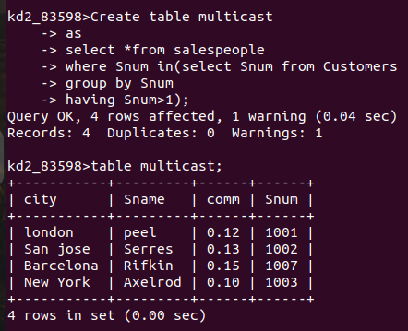
-> having Snum>1);

Que 2 -: write a Command That deletes all Customers with no current orders.

kd2_83598>delete from Customers
-> where Cnum not in(select Cnum from orders);
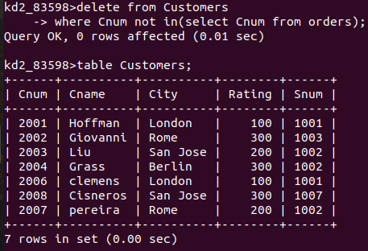

Que 3 -: Write A Command That Increases by twenty percent The Commissions of all salespeople with total orders above 3000.

kd2_83598>update salespeople
-> set comm=comm*.20
-> where Snum in(select snum from orders
-> group by snum
-> having Sum(amt)>3000);
